**New Bootstrap Projected Started – Admin Dashboard**

* **Project overview**
* Side navbar
* Horizontal navbar
* Cards
* Progress bars
* List of lines with insert and delete operation icons, etc,.
* **Side Navbar**
* For all breakpoints
* Navbar with lg-3
* Toggler
* Title
* Options in side navbar with icon

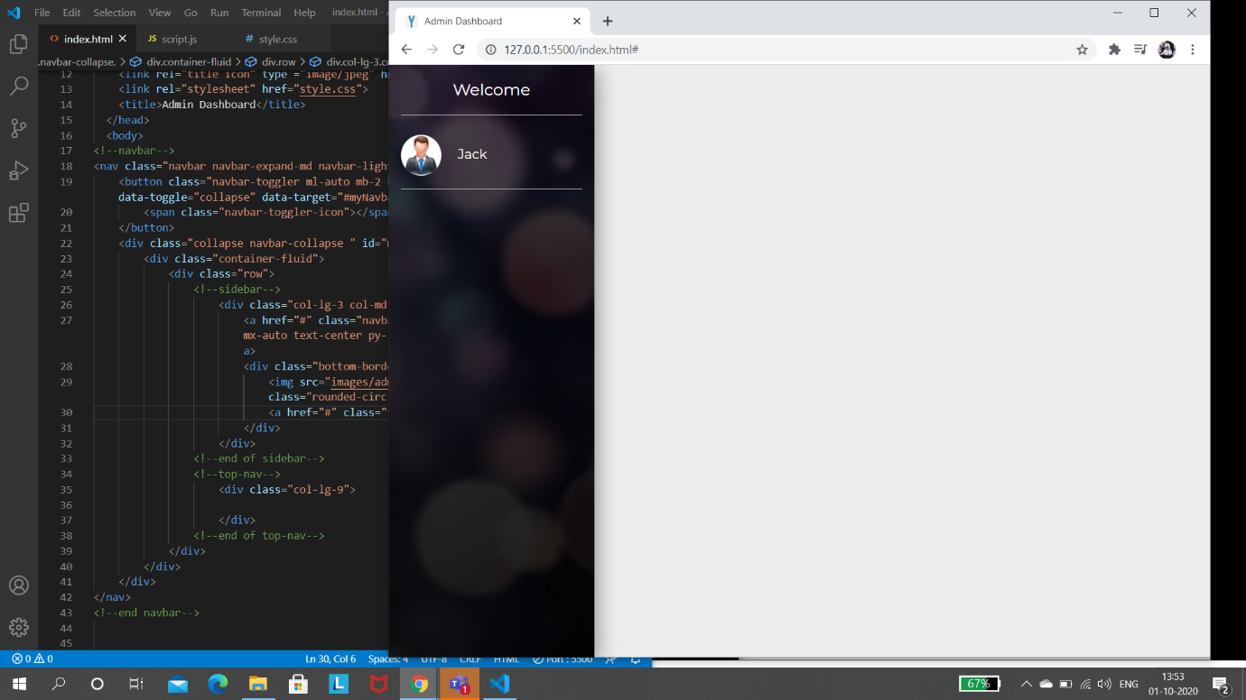

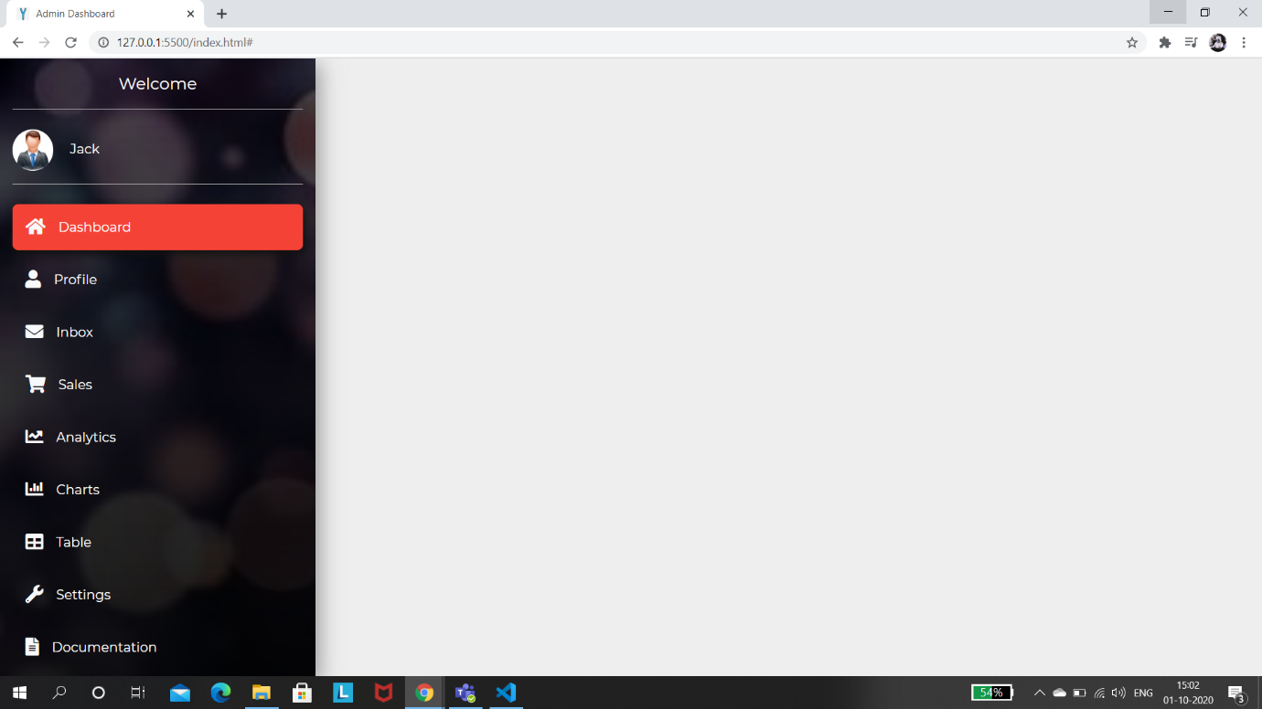

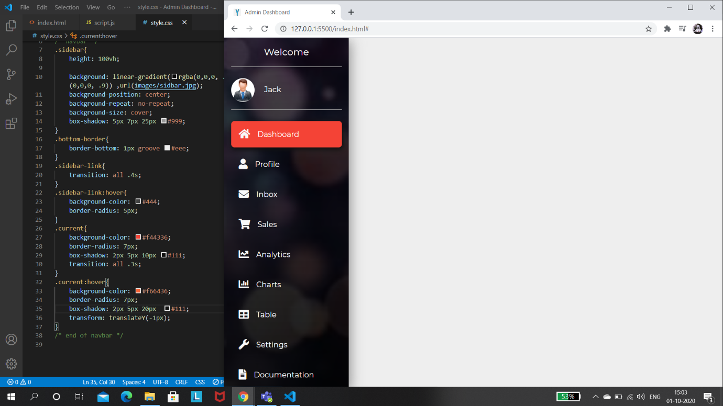

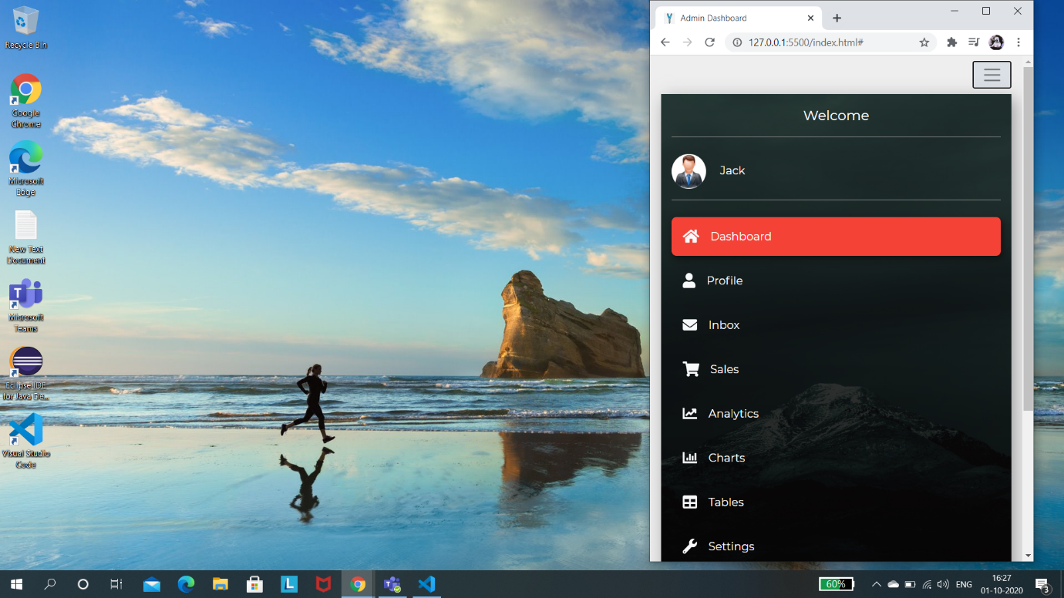

s

* Admin image and name, etc.,
* **Horizontal Navbar i.e. 2nd Navbar**
* Current title
* Search box and button
* Chat ions and bell icon
* Logout icon
* **Modal**
* Operation for logout option i.e. icon
* Alert dialogue box with conformation button in dialogue box.

